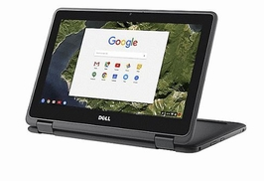
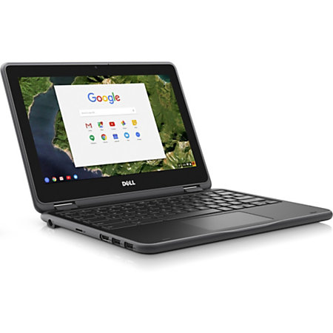
Oak Street Parent Teacher Organization
Registration ID 37-5-27343

5th Grade Computer Raffle

Buy a raffle ticket (or more) for your favorite 5th grader to win a Dell 2 in 1 Chrome Notebook with touchscreen! It includes pro support plus with accidental damage
for 3 years. Each class will have one winner!
The retail value is $599. You will support the funding of current 5th grade PTO events at Oak Street and help five students be prepared for middle school.

Eligibility for Raffle Ticket:
- Student must currently be a 5th grader enrolled at Oak Street School to win.
- Each 5th grader's family may purchase a maximum of $100 in raffle tickets.
Drawing:
- Five winners (one per classroom) will be selected from all eligible entries, which must be received no later than 3:15 pm on Friday, June 2, 2017. Winners need not be present to win.
- The raffle will be drawn at the Oak Street School's 5th Grade Party on June 13, 2017 at 2:00 pm in the Eagles' Cafe. - No substitution of the offered prizes will be made and no cash will be given in lieu of the prizes.

Complete below, detach, and return with payment in an envelope addressed to "5th Grade Party Raffle".
-----------------------------------------------------------------------------------------------------
Parent's First & Last Name: _____________________________________________
5th Grader's First & Last Name: _____________________________________________
One (1) ticket for $10, Three (3) tickets for $25, Six (6) tickets for $50, Ten (10) tickets for $75
# of Tickets:____________ = Amount Enclosed: $____________ (max. $100)
- Each 5th grader can purchase between one (1) and thirteen (13) tickets for a total ranging from $10 to $100.
- Enclose cash or one check per 5th grader payable to Oak Street School PTO.
- Return in an envelope addressed to the "5th Grade Party Raffle" with your child's name and teacher in the return address area.
- All tickets must be purchased no later than Friday, June 2, 2017 at 3:15 pm. Tickets will be entered in the drawing on your child's behalf based on the amount of the check received. A receipt will be sent home for your records.

Please email any questions to Janine Cordeiro at janinecordeiro19@gmail.com or Nancy Fukushima at nancyken@optonline.net

