5th Grade Fundraiser

Join us for a fundraiser to support Oak Street 5th Grade. Come in to The Rebecca Collection at 2 Mine Brook Road in Bernardsville between March 19 and March 21 and mention that you are supporting the cause so that a portion of the proceeds will be donated to the Oak Street 5th Grade. Get your Easter shopping done while supporting our school!
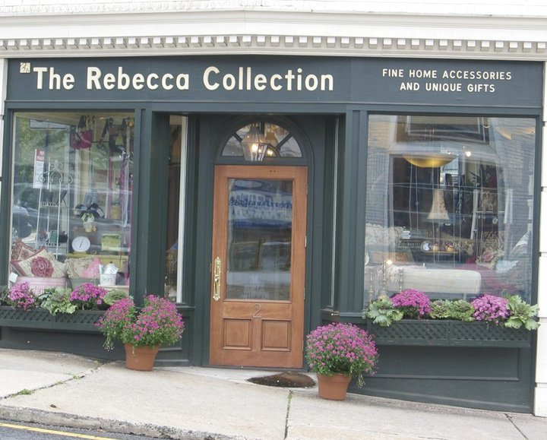
Questions ? : Email Christine Kanne ckanne1@gmail.com

