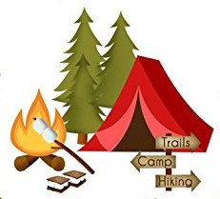
Calling All Families!

The Family Reading Night Committee needs your help. Our theme this year is Camping Out with a Good Book.

We are looking to borrow:
Pop up tents
Artifical Christmas trees
Galvanized tubs
***We will begin collecting these items in February.

I hope you are as excited as we are to camp “under the stars” in the café on March 1st!
Carly Long Clong@bernardsboe.com
Melissa Baron Mbaron@bernardsboe.com

